

**PPR – PSS XXX22-211-01**

**PO# PWHY-19-0074**

**ENTITY**

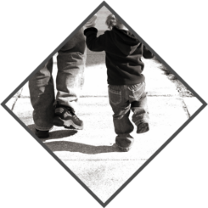

February 2, 2023

©2022 Precision Safe Sidewalks, LLC.

**Presented to:** Name, Title

**Submitted by:** BDM, Title

(800) 734-8891 ext. 305 M: (xxx) xxx-xxxx | [xxx@precisionsafesidewalks.com](mailto:xxx@precisionsafesidewalks.com)

**SIDEWALK MAINTENANCE SAVINGS AND ENVIRONMENTAL IMPACT**

This summary has been prepared for:

**ENTITY**

**Name, Title**

Address

Contact Phone | Contact email

**INTRODUCTION:**

Precision Safe Sidewalks is a company whose focus is to help its customers make their walkways more pedestrian friendly. We do this using proprietary and patented technology to assess sidewalk infrastructure for trip and fall hazards and through the use of precision cutting technology to make permanent repairs.

This unique approach has afforded North Carolina, Virginia, West Virginia, the District of Columbia, Western Pennsylvania, Albany-New York, municipalities, communities, and businesses the ability to meet the requirements of the Americans with Disabilities Act (ADA), minimize liability, and make their sidewalks more pedestrian friendly – at more reasonable rates than conventional alternatives.

**WORK SUMMARY**:

Precision Safe Sidewalks was awarded a Purchase order for trip and fall hazard removal from the project name to make repairs to trip hazards ½” to 2½” in height for the following areas and classes:

|  |  |  |  |
| --- | --- | --- | --- |
| **SIDEWALK HAZARDS REPAIRED\*** | | | |
| **LOCATION** | **CLASS** | **HAZARDS** | **PRICE** |
| **XXXXX** | Least Severe |  |  |
| Severe |  |  |
| Most Severe |  |  |
| **TOTAL** |  |  |  |
|  |  |  |  |

*\* Precision Safe Sidewalks, LLC delivered $-,--- of sidewalk repairs.*

*Actual invoicing for the contract was $totalHazardCost.*

There are also curb hazards at points of egress adjacent to the curbside sidewalk hazard portion of the project. We repaired a total of curbLength linear feet of curb at points of egress.

|  |  |  |
| --- | --- | --- |
| **CURB HAZARDS REPAIRED** | | |
| **LOCATION** | **LINEAR FEET** | **PRICE** |
| **XXXX** |  |  |
| **TOTAL** |  |  |
|  |  |  |

*\* Precision Safe Sidewalks, LLC delivered $47,917 of sidewalk repairs.*

*Actual invoicing for the contract was $totalHazardCost.*

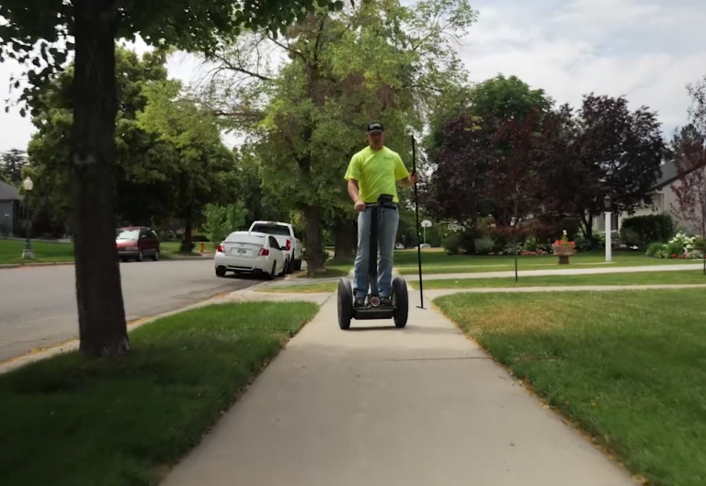**How did we find the hazards?** Precision’s survey crews began work in the project area inspecting every sidewalk panel. While a portion of the area was covered using Segways, some of the areas had to be covered on foot because of the hazard density and weather.

Using the company's proprietary survey application and hand-held computers, they located every hazard according to the Entity’s specifications and recorded its attributes while capturing the GPS coordinates of each hazard location. In total more than [X] miles were logged to cover the project area.

**How were the hazards repaired?** Precision's repair technicians used the survey information to locate the hazards and repair them with the company's patented process and cutting technology.

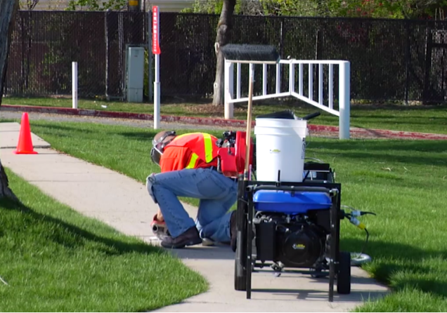

For each repair, the company guarantees:

* the hazard has been removed, completely, across the entire edge of the sidewalk
* the slope of the repair complies with the requirements of the ADA
* the slip resistance exceeds the OSHA recommendations for walkways
* adjacent sidewalk panels or landscaping were not damaged by the repair

Technicians recorded the specifications of every repair and this information was provided to the Entity in an auditable invoice.

**TRIP AND FALL HAZARD REPAIR**

**PROCESS**

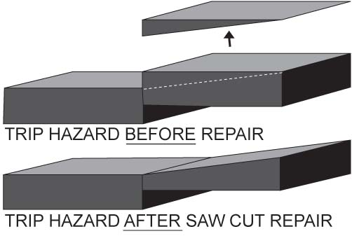

**QUALITY REVIEW:**

After completing repairs on each street, Precision's inspectors visited every repair to confirm all scheduled repairs had been completed. Once again they covered every sidewalk panel on every street to identify trip and fall hazards that can only be repaired by the more expensive process of demolition and replacement (D&R). The attributes and GPS locations of each hazard needing to be demolished and replaced were captured and provided to the project manager.

Using this process, Precision's crews systematically covered every sidewalk panel in the project area, finding and repairing **340 trip and fall hazards and curbLength linear feet of curb at points of egress, which** **restored tripHazardSqft square feet of sidewalks and curbLength linear feet of curb.**

**GEOGRAPHIC INFORMATION SYSTEM LAYER:**

The location data collected during the survey, repair, and inspection processes can be put to valuable use by the Entity. This data can be easily imported into the Entity's Geographic Information System (GIS) using the GPS coordinates of the repaired hazards. This information can be useful in confirming the Entity's sidewalk locations and as a management tool to organize ongoing sidewalk maintenance activities. The map below is a snapshot of the project area taken from the Company's GIS. It shows the number and locations of hazard repairs completed in the project:

**REPAIRED HAZARD LOCATIONS**

<if applicable, remove D&R section if separate D&R report is prepared; some customers do not want D&R in the PPR>

The picture below shows the D&R locations – panels that could not be repaired with this process and need to be replaced. This information can be useful by allowing crews to be dispatched efficiently while keeping the repair activities organized in the project area. When each area marked by a green dot has been repaired, the Entity's Managers know that trip and fall hazards have been completely removed from the project area.

**D&R LOCATIONS**

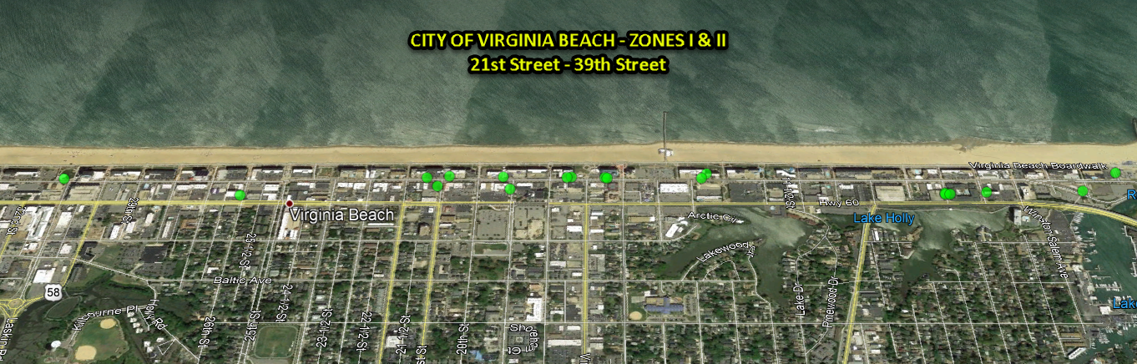

**PRICING SUMMARY**:

The total cost of all surveys, repairs, and inspections in the project area was **$#,###**.

Repairs were completed in 6 days, while keeping the sidewalks in service and minimizing inconvenience to pedestrians. No heavy equipment or traffic control was required, and all areas were cleared of any debris. The repair areas were left clean and free of trip hazards within the scope of the project.

COST SAVINGS:

Using information provided by the Entity, we calculated that by repairing the sidewalks, the Entity **saved more than $savings_** over traditional D&R methods. Based on a replacement cost of $15.00 per square foot provided by the Entity, D&R alone would have cost the Entity $totalDnrCost for the tripHazardSqft square feet of sidewalk and curbLength linear feet of curb at points of egress**.**

ENTITY

COST SAVINGS¹

Total Estimated Cost for Demolition and Replacement = $totalDnrCost

*delete after updating table associated with pie chart. Savings = _sav_, Cost = _cos_

|  |  |  |  |  |  |  |  |
| --- | --- | --- | --- | --- | --- | --- | --- |
| **Post Project Review Calculations** | | | | | | | |
| **¹** | **COST SAVINGS:** |  |  |  |  |  |  |
|  | Based on demolition and replacement (D&R) costs of $15.00 including: | | | | |  |  |
|  | Cost of concrete |  |  |  |  |  |  |
|  | Labor to break up and remove existing concrete | |  |  |  |  |  |
|  | Labor to pour, form, level, finish, float & cut control joints | | |  |  |  |  |
|  | Fuel for multiple site visits to repair or break-up, remove, pour, remove forms, and restore adjacent items | | | | | | |
|  | Equipment such as a backhoe, vehicle to transport backhoe, utility vehicle, and dump truck to remove debris | | | | | | |
|  | Miscellaneous materials to prepare concrete | |  |  |  |  |  |
|  | Landscaping repair |  |  |  |  |  |  |

*Change $15.00 above to dnrPricing

ENTITY RESIDENT COMMENTS:

Our Survey and Repair Technicians had several contacts with business owners and pedestrians who took note of the work the Entity was doing to repair the sidewalks.

The response to the City’s efforts to make the sidewalks safer was favorable.

SAFETY INCIDENTS:

There were no safety incidents during this project.

**ENVIRONMENTAL SAVINGS:**

Use of the Precision Safe Sidewalks service is a Green Building Practice, affording the Entity the opportunity to save natural resources as shown in the table below.

Using calculators provided by the Environmental Protection Agency (EPA), the Entity has saved from TL to TH tons of waste concrete from a landfill. A projected totFuelSaved gallons of gas (fossil fuels) have been saved by repairing versus replacing the concrete.

Production of totCO2 metric tons of CO₂ or Greenhouse Gas emissions has been avoided by repairing the sidewalks and also recycling all concrete removed during the repair process.

|  |  |  |  |  |  |
| --- | --- | --- | --- | --- | --- |
| **ENVIRONMENTAL SAVINGS** | | | | | |
|  | | | | | |
|  |  |  |  |  |  |
|  |  |  |  |  |  |
|  |  |  |  |  |  |
|  |  |  |  |  |  |
|  |  |  |  |  |  |
|  | **Natural Resources Saved²** | | | **Fossil Fuels Saved³** | **Greenhouse Gas Emissions Avoided (Concrete + Fossil Fuels)⁴** |
|  | **Total Cubic Ft** | **Waste Concrete Low (Tons)** | **Waste Concrete High (Tons)** | **Gallons** | **Carbon Dioxide - C0₂ Metric Tons** |
|  |  |  |  |  |  |
|  |  |  |  |  |  |
|  |  |  |  |  |  |
| **ENVIRONMENTAL SAVINGS:** | | | | | |
|  |  |  |  |  |  |
| **² Natural Resources Saved:** | |  |  |  |  |
| Waste concrete removed and placed in landfills | | | |  |  |
| New materials and resources to replace concrete that was removed | | | | |  |
|  |  |  |  |  |  |
| **³ Fossil Fuels Saved:** | |  |  |  |  |
| Hauling equipment to and from the site to remove sidewalks | | | | |  |
| Operating backhoe equipment to break up and remove concrete | | | | |  |
| Round trip transportation of estimated tons of debris to the landfill | | | | |  |
| Roundtrip transportation of new materials to replace the removed sidewalks | | | | |  |
|  |  |  |  |  |  |
| **⁴ Greenhouse Gas Emissions Avoided:** | | |  |  |  |
| Use EPA Greenhouse Gas Equivalencies Calculator to calculate estimated metric tons of CO₂ - Carbon Dioxide | | | | | |
| or CO₂ equivalent gases that will not be produced as a result of repairing the trip and fall hazards on sidewalks | | | | | |
| vs. removing the sidewalk panels and sending them to the landfill. | | | | |  |

**CONFIDENTIALITY:**

This copyrighted material is presented by Precision Safe Sidewalks, LLC. to the Entity for the purpose of evaluating the cost savings and environmental impact of our trip and fall hazard removal services. These literary, graphic, and pictorial works may not be reproduced or retransmitted in any form and the information presented in this proposal may not be disseminated without express written consent for purposes other than this evaluation.

**PRECISION SAFE SIDEWALKS WORK EXAMPLES:**

|  |
| --- |
|  |
| **BEFORE** |

|  |
| --- |
|  |

**AFTER**

**Precision Safe Sidewalks, LLC.**

(800) 734-8891

[www.PrecisionSafeSidewalks.com](http://www.PrecisionSafeSidewalks.com)

**Raleigh NC | Charlotte NC | Mechanicsville VA**

**Charleston WV |Washington DC | Albany NY | Western PA**

*The only Precision Concrete Cutting Company exclusively serving*

*North Carolina, Virginia, West Virginia, District of Columbia,*

*Western Pennsylvania & Albany-New York.*

|  |  |
| --- | --- |
|  |  |
|  |  |